Date: 28 April 2017

Attendees: David, Gary, Keyi, Ji Kin, Tessa, Jingwen

**Agenda:**

1. Purpose of Application
2. Brainstorming slides

• Determine what customers hope to achieve – so when prof asks the X-Factor there is a purpose: - Certain level of engagement (that is measurable) – internal & external - Main reason: Employee’s journey. - Doesn’t make sense to just revamp the website, think of something to value add - Go on the website to apply job posting etc (like planned), then when accepted the job use the mobile app (staff discount, job environment etc etc) - Create an event for staff to rsvp etc etc, communicate between the staff, induction learning, staff at retail stores – no intranet available, duty roster - Issue with retail sector – front line staff don’t know the company

**Application(Now, a mobile friendly employee-engagement website)**

* Group is concerned about school agreeing on the development of BOTH website and app 🡪 feel the school will only grade on the mobile app
* Group wants to develop for ANDROID (FJB can consider getting someone else to develop the ios next time)
* Another alternative: The “app” is just a mobile friendly website that serves all the functions of the app
* **OK MOSTLY CAN AGREE: WE WILL DO A WEBSITE, BOTH EMPLOYEE RECRUITMENT SITE(FJB’s external) + EMPOYEE ENGAGEMENT SITE. Make sure that it is a website, so the FJB staff can log in to the ‘employee engagement’ part of the website to access employee-exclusive information and functions**
* App potential functions: events, healthcare information, leave information
* MAIN TARGET AUDIENCE: TIRED EMPLOYEES???????????? Retail??? Or backend???
* Integrating simple employee-ish things such as Outlook calendar
* **FUNCTIONS THAT FJB WANTS FOR THE EMPLOYEE ENGAGEMENT SITE:** 
  + Those on email
  + **Point 1** – What’s the username? FJB proposes NRIC, but other alternatives include employee’s emails or employee number (coz of security reasons)
  + **Point 4** – how to receive notifications? Just keep the notifications on the website itself, OR automated email sent for event notifications/new event invitatio
  + **Point 5** – link to aviva website so can just view a list on email. We can TRY to lnk it with Aviva API, to achieve additional functions like “find the nearest clinic”
  + **Point 6** – **No longer a forum.** It would include an FAQ section and a simple textbox for people to key in their questions.

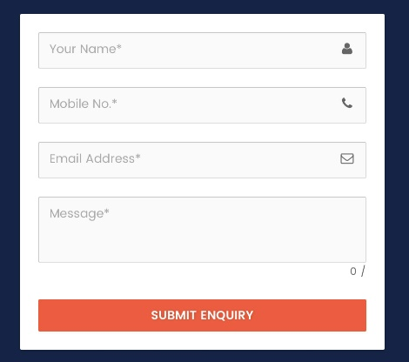

* + *Bonus function they wanna consider: having a platform for FJB to arrange rides back from the office to areas in the east/north-east similar to the concept of GrabShuttle. They still need to get more input from their employees*
  + *Bonus function no. 2 🡪 Time roster*

**Website**

* Group thinks development of website is not as heavy, because we are more focused UI and content of website
* If website is ultimately chosen as the sole focus of the project, we will enhance in further make it more dynamic and sustainable, scalability and long lasting 🡪 refer to above point

**Requirements**

* Revamping of website may not be as value-added
* What FJB wants: Employee engagement, enhancing the employment process
* The mobile app is not the same as the website. It’s about employee engagement INSIDE the company, internally within the employees. Website is about recruitment of external employees, interaction of external parties
* What is the wow factor of this project?????? So far we don’t have one that we can solidly present – Possibly the event planning??
* Darren’s suggestion: The integration of the mobile app and the website is about enhancing the employee journey, the recruitment done through the website, the mobile app is available for use for the employees once they join the company (all the information they need, organization of events for staff bonding, communicate with other staff). Coz currently FJB does not have an intranet, new employees and retail staffs have almost zero orientation. It’s hard to build a company culture, to instil it in the new staff from day 1 (retail staff form majority of fjb)
* Common issue for many fashion shops: low-level staff are out of touch with the company’s vision, culture and know nothing about the companies other than the products.

**EMPLOYEE RECRUITMENT SITE: Ideas**

* + FindSGJobs.com
  + Jobstreet – jobstreet API? Remember that jobstreet is quite strict with what companies post and companies pay to put up postings
  + Facebook link?
  + Video interviews – just online video uploading. Mr HR guy don’t like but the video is just a shallow layer of filtering. Same concept as FTW. **Not** the end point of the recruitment, it’s just a bonus.
  + Need to ask them about their partner.

***POS System (To refresh our memory)***

* + ***For every referral code that has been used/redeemed, a new voucher code would be newly generated and input into database with mySQL***
  + ***From database, the new voucher codes can be pulled to POS***
  + ***\*\*\*Prevent reuse of voucher codes – randomize?***
  + ***Must keep track of every referral code that has been used/redeemed. Do NOT duplicate voucher codes.***
  + ***NOTE: we do not touch the front end of the POS System at all. We just handle the database and some information input***